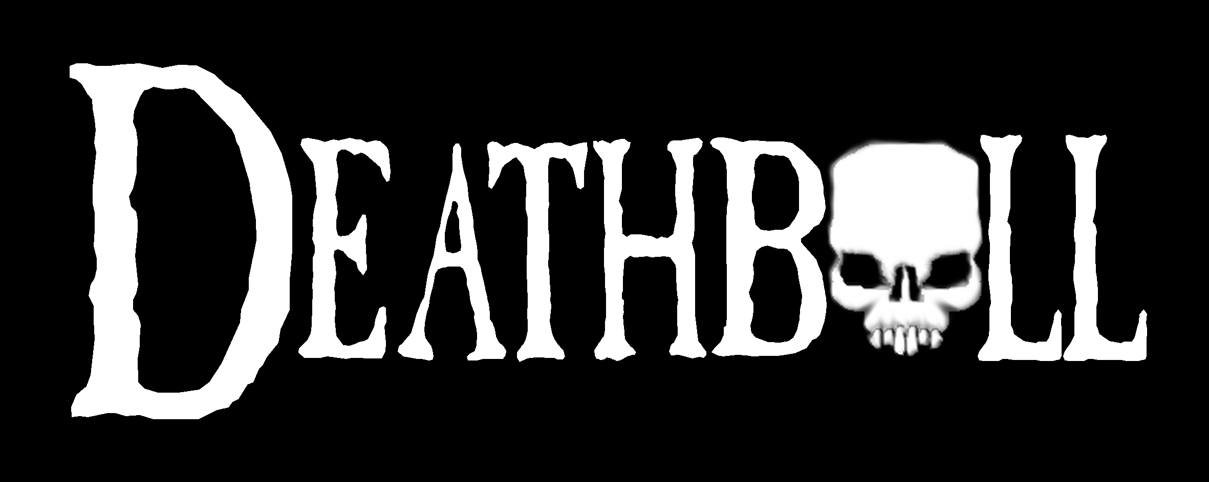
Core Rules

v1.5 (14/9/04)

by Chris Webb
and Andy Foster

Introduction

Morica is a dark realm, famed throughout the Netherhells world for its bloodthirsty citizenship and warmongering politicians. In such a climate of cruel violence the dark Lord Scaldis II has secured his people’s support primarily, it would seem, with the game of Deathball.

Dressing it up as tribute to his demonic master, Baal the Butcher , Scaldis pits teams of slaves, prisoners and gladiators against those of neighbouring kingdoms’ Dark Lords in massive, blood-drenched, crowd-pleasing spectacles. Often a series of games will be announced during religious events. These Unholy Days are much anticipated by the common scum that live in the lands of Morica. Many of the crowd will have favourite combatants who might have survived one or two games: but if they die that day, their fans will only enjoy themselves the more for it!

The team’s objectives tend to revolve around the placing of heads and the inflated organs of sacrificial victims into stone goals or onto mighty altars, while at the same time killing and maiming as many of the opposing dark lord's fighters as possible. In Deathball, deaths are frequent and spectacular: the “ball” is always the secondary consideration. It is the roar of the crowd, that greets the players with howls of lust and fury as gold changes hands; the laughter of the Dark Lords as another creature is slaughtered; the thrill and relief of surviving; this is what Deathball really is!

Ranty bit

What’s written here is not hard or fast, and (much like Chris’s essays) probably isn’t correct, accurate or well-researched either. However, it is fun, and so if you should find anything here that’s stopping this simple beer-and-dice game from being just that, then please change it. Make the arena a different shape, change the stats, whatever, as long as you agree it with your opponent.. We tried not to make nay monsters that were ‘unkillable’. When that failed, we stuck lots of them in instead so everyone had a chance to get them on their team. The main purpose is not really to win or lose the game, it’s to marmalise your enemies players and maybe score a goal or two along the way! Have fun!

What you need to play

You will need:

- An opponent – available from all good hobby stores.
- An arena – downloadable one now available at http://www.heresyminiatures.com/deathball ! But feel free to make your own or use whatever you have available – squares, hex-grids, inches, whatever.
- Models - 2 teams (or more if you like!) of 6-8 models each, and whatever you want to use to represent traps, wandering creatures, crowd members etc..
- Violence Dice – special 6-sided dice (available from Heresy eventually!) They (will) feature skulls on three sides, shields on two and a pentagram on the sixth. If you use a D6 to represent this, count 1,2,3 as a skull, 4,5, as a shield and 6 as a pentagram
- D10 and a D20 – necessary for generating teams and traps.
- Pen and paper – for noting down goals and wounds.
- Drinks and snacks – no gaming session is complete without them.

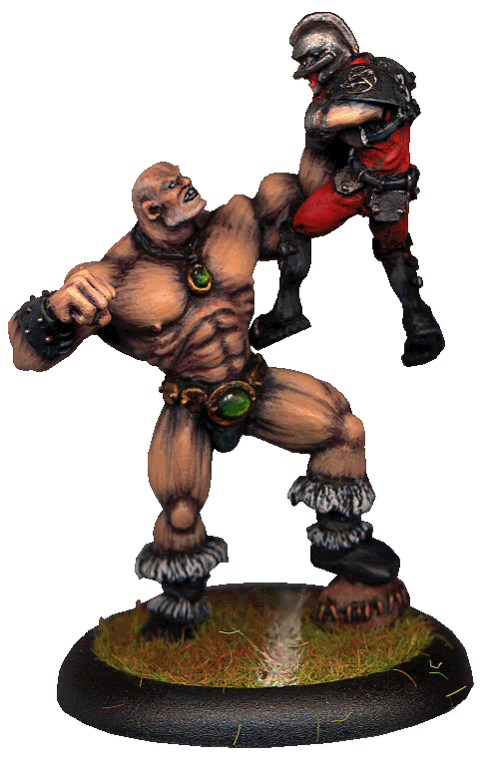
The Players

‘Players’ is a slight misnomer for the poor souls forced into the arena for the crowd’s amusement. Dark lords are at their most resourceful when forming teams, releasing prisoners from the dungeon, training the most vicious of their pets and even capturing monsters. There are even a few players who volunteer for the arena confident in their own ability to handle whatever’s in there. The various players are reflected in game terms with these tables:

Statistics:

 | move | attack | defence | agility | wounds | skills
Barbarian | 4 | 4 | 4 | 3 | 1 | berserk

Statistic Explanations:

Move How good the model is in running to things, past things and from things. The amount of squares a model can move in a single ‘run’ action

Attack How strong, pugnacious and vicious the model is. The score is how
many dice the model rolls

Defence How tough, well-armoured and thick-skinned the model is or how
good at fighting. Some creatures are naturally better than others, some
have training to fall back on. This score is the number of dice a model
rolls when testing for something

Agility How good the model is at handling the ball, dodging things and jumping around like a monkey with a chilli up it’s…well, you get the idea. Again, this score is the number of dice the model rolls when testing for something, although sometimes it can be a test on a D6 where the model must roll equal to or under its agility to pass a test.

Wounds How much damage a model can take before it’s removed as a causality. Most man-sized models can only take one wound before they start to roll around on the floor in agony.
Skill Explanations:

Many creatures and fighters have natural or learned abilities that give them bonuses or penalties in the arena. Such skills are noted in the creatures table after their stats. The following table gives explanations and rules for the various skills, some of which are catch-all titles to save repetition of effects. For instance, fireballs, lightning bolts, and even dwarf tech is lumped under magic missiles, as they all have similar end results i.e. people dying at range!

Armed | As a general rule of thumb, Deathball fighters are unarmed. Dark lords are understandably reluctant to give their prisoners weapons. (Peoples from other realms find this strange considering the ready availability of weapons to Morica’s citizens.) An armed model is allowed to re-roll one violence dice when attacking other models. Armed models may not throw or catch the ball unless they drop their weapons. If they do this, they do not count as armed for the rest of the game – as soon as they drop their weapon, a little hatch opens up and something grabs it, taking it underneath the arena…
Armoured | Armour is also a luxury for Deathballers, as the dark lords trust only their veteran players to give it back when the match is over. An armoured model may re-roll one violence dice when making tests with their defence, but also has their agility reduced by 1.
Acrobatic | Acrobatic exploits can come in surprisingly useful in the arena, players can leap up walls to catch balls, cartwheel over attackers and even fight off packs of velociraptors with the power of amateur gymnastics. A model that is acrobatic can re-roll one dice when making tests that involve their Agility. They may also leave combat without being attacked.
Animal | Creatures such as lurkers and hellbeasts can’t understand, (or choose to ignore) the basics of Deathball, such as scoring goals. However, they are valued in the arena thanks to their destructive potential. Animal models are not allowed to pick up the ball, throw or catch it, score goals or tackle other models for the ball. Animals are conditioned to attack opponents automatically and will move towards the nearest model from the opposing side to attack it. If that model is in combat with another of the same animal, then it may ignore that model in favour of an unengaged opponent further away, or join in the attack on that model.
Berserker | The model is able to go into a berserk rage once per match. It adds 2 extra attack dice and loses one defence dice for all the following turns until it loses a combat, at which point its rage is knocked out of it and its stats return to their previous level.
Bloodlust | Similar to berserker in that the model froths at the mouth, except that it kicks in by itself and only after the model wins a combat, plus the model is hungry for flesh to munch on. Once, bloodlust takes hold of a model it remains in effect until the model is taken out of the arena. The model adds 2 to its attack dice but deducts 2 from its defence dice. If it kills a model (not Undead or a model with the You Don’t Dare Kill It rule) it must spend the next whole turn stationary, whilst it feasts on its foe and may not perform any other actions.
Demonic | Demonic creatures may use pentagrams as skulls or shields on their dice as their master’s dark magic flows through their veins. They are immune to Poison of all kinds and Stench of Evil
Dreg | These poor creatures have been starved and tortured for too long in the dungeons before being released onto the field of play. They have one less point than a normal creature for each stat, to a minimum of 1. They are mainly used to entertain the crowd in display games
Entangle | The creature spits sticky webs, viscous fluid or is armed with a net to trip foes. Opponents must avoid this whilst fighting the creature and have their attack score halved, rounding up.
Favoured | The model is much favoured by its dark masters. If it is reduced to -2 wounds or less, it is NOT removed from the game like other models, instead count it as being at -1 wounds. It may also re-roll the recovery dice, i.e. if it does not roll a pentagram to recover, it may try again, once, each turn.
Flight | Although a powerful magical spell (or sometimes a domed ceiling) prevents occupants from escaping by flying away, some creatures have wings that allow them to make a single double length move in a straight line over the heads of other players. A creature with wings ignores opponents in its path and can move to an empty square within range of double its move. However, an unengaged opponent with the Armed skill who lies under the flight path may take a swing at the flying creature whilst it passes overhead. Roll to attack/defend as normal, then finish the creatures move if it survives. If the attack is successful and reduces the creature to 0 wounds, the creature lands in the first empty square after the attacker along the flight path, and drops the ball. You may not perform another action after a flight move, it counts as 2 actions.
Holy Aura | The model fights for the Light and its very presence causes pain to the creatures of Darkness. Any Undead or Demonic opponent in an adjacent square to the Holy model, loses their ability to use pentagram results, and may not re-roll any of the Holy models dice.
Is That Yer Best? | The creature is unusually stubborn and refuses to accept that is injured! The creature ignores the first wound it suffers from each new opponent. The crowd love it!
Leap | Some creatures can propel themselves into the air using their powerful musculature or other skills, and may jump over the heads of their enemies. This counts as 1 action, but no other actions may be performed that turn after a leap, except a tackle. i.e. You may perform a leap after moving normally, but not 2 leaps in a row.
Magical | Some models are enslaved magicians, blessed by daemons, or may have been visited by gypsies as a child. This gives them an edge in the game. A magical model is allowed to count any pentagrams rolled on the violence dice as whatever they needed to roll (e.g. shields when catching, skulls when tackling).
Magic Missiles: | The creature can throw or spit balls of (flaming/freezing/lightning/other) energy at it's opponents, a distance of 4 squares. If the creature rolls a skull on one dice, the attack is on-target, causing 2 dice worth of damage that can be saved in the usual manner by the victim. Magic missiles may not be used if the creature is carrying the ball!
Moves Underground | The creature tunnels below the surface of the arena(this requires special preparations by the arena’s groundstaff to make sure there is enough dirt to fit the creature in, if the arena is built over the dungeons, as is often the case) and only surfaces to attack, bursting from the groundto devour its victims. When it moves, it may move underneath any model in its path without penalty. Creatures that use move underground cannot be attacked whilst underground, and are usually subject to the ‘animal’ rules too.
Poison Attack | The creature injects its opponents with lethal or paralysing poisons by biting, stinging or clawing them, or perhaps is armed with a poison blade. For each of the creatures attack dice that rolls a skull, it may force a re-roll of its victims shield rolls. So if a Monstrous Spider rolls two skulls, and its opponent rolls 3 shields, the spider player may force the opponent to re-roll two of the shields. The second result stands even if it’s more shields. No effect on Undead or Demonic creatures
Poison Spines | The creature is covered in vicious quills and barbs which ooze a lethal poison. It forces an opponent to re-roll one defence dice of its choice, or to re-roll one attack dice. If the attack dice comes up a pentagram (a 1) then the creature may count this as a wound and the attacker must roll a single defence dice (immediately) to save against it. The creature may use this ability once per opponent. After that they learn to avoid the quills...or they die! No effect on Undead or Demonic creatures
Regenerate | If the model is below its full complement of wounds then it recovers a wound automatically at the end of each of its turns. If it has been removed as casualty (i.e. reduced to -1 wounds or less) then this skill has no effect.
Smite | By concentrating their energy into one unstoppable blow, the model may force an opponent to re-roll their whole defence dice once per opponent (second result stands even if better)
Splat! | Some models are so small and puny they make funny squishy noises and big puddles of blood with very little effort on the behalf of the attacker. Models that go splat! are removed as dead as soon as they take a wound. The crowd goes wild with appreciation and throws things at the corpse/stain  .
Stench of Evil | The model reeks worse than an ogre’s jockstrap. Any attacker must deduct one die from its Attack rating when attacking due to the tears in their eyes. This skill has no effect on models with stench of evil, or Undead – they either stink themselves and don’t notice, or can’t.
Undead | Undead creatures may use pentagrams as shields on the dice as they are very hard to kill completely – they tend to put themselves back together or have a supernatural toughness! Undead creatures are also immune to Poison Attacks of any kind and Stench of Evil.
Vampiric | Vampiric models may restore 1 wound to themselves if they beat an opponent in combat. They cannot use this ability against Undead or Demonic creatures
Were-creature (type) | (Werebear/Werebrute) - A muscular hairy creature similar to an ogre in strength - Add +2 Attack dice to the base profile, and add +2 to wounds. Suffers Berserk, Bloodlust  (Werewolf) - Stronger/slower than a werelion and faster/weaker than a werebrute: +1 Move +1 Attack, +1 Defence, +1 wounds, Suffers Bloodlust, regeneration  (Werecat) (eg were-cheetah) - fastest/weakest of the were-types, although were-lion/were-tigers would be similar to were-wolves instead. +1 Move, +2 Defence, +1 Wounds, Acrobatic, Berserk  (Werespawn) - demonic creature bursting with poisoned spines and claws etc. Leathery or armoured skin. Strong and fast. The most lethal of the were types, inflicted usually by surviving the bite of a true Hellspawn (rare). Other were types are created when the victim survives the attack of either a Hellbeast, hellhound, Helltiger, or any Were-creature.  +2 Attack, +1 Defence, +3 wounds, Bloodlust, Poison Spines, Demonic.  Were’s are used as their normal base creature until either they are attacked or the controlling player chooses to have them transform into their were form. Changing form takes two actions to do voluntarily. If the were transforms as a result of being attacked, it defends itself as its base creature in the first round, then must spend the next round transforming into its were-form.
You Don’t Dare Kill It | The creature is covered in poisonous spines or has molten lava or virulently acidic blood or similar. Upon it's death the creature explodes showering the nine adjacent squares with deadly fluids and shards of bone, or flaming gases, etc. Anyone in those squares takes two wounds, which they can try to stop using their regular defence roll. If applicable they may instead try to use Acrobatics to avoid the spray of death, as per a normal attack. If they do this, they are placed in the square directly behind where they were standing. If they cannot move to an adjacent, unaffected, empty square, they may not use Acrobatics to save.

The Arena

We now have a fantastic full-colour downloadable arena on our website – http://www.heresyminiatures.com/deathball - a circular arena marked out with 30mm squares. These rules are written assuming that you’re using this arena. However, if you aren’t, then simply adjust the rules accordingly – for example, instead of moving 1 square, move 1 hex or one inch. If you make your own arena, then it would be a good idea to include:

Goals – 5 altars placed along the circumference of the arena. These are usually huge stone demon heads with gaping maws, known as ‘the Five Mouths of Baal’. Placing the tribute offering in a mouth scores a goal. (Note: if you are using a different shaped arena, then just place altars in the middle of each flat side to your own taste.)

Centre Spike/Pillar – holding the various tributes to be used as balls – feral heads, goat heads, actual balls made from the skin and organs of victims, that sort of thing. For ease of reference in the rules, these sacrificial offerings are referred to as balls. The centre pillar is usually in the centre of the arena (oddly), sometimes a magical portal may be used to drop the new ball into the arena after a goal is scored.

Team Entrances – two or more tunnels or small doors allowing new gladiators to enter the arena. Sometimes trapdoors are used in the arena floor or magical portals may even be created as and when required…

What you need to know

Basic Concepts

During a turn a player gets to perform actions with every model in his team.

A model can perform two actions during its turn unless it starts the turn in a square adjacent to a standing opposing model - in which case it can only perform one. (A standing model is defined as a model on a positive number of wounds). This represents the models tussling, trying to lose their marks, or just cowering in fear of being hit. When a player has performed all the actions they wish with their models, then the other player takes their turn.

A model must finish performing an action before starting another. A model, for example, cannot move two squares, hit an opponent, and then finish his move action. Players are not forced to complete all their actions with one model before moving on to the next.

Starting the Game

Games start with the ball in the centre square, and each team arranged in a mutually-agreeable fashion in their half of the arena. One model from each team should be placed next to the centre square in order to fight for the ball and hence the first turn.

The two models competing for the ball should both roll a number of violence dice equal to their attack value – the model rolling the most skulls (re-rolling in the event of a tie) gains the ball, and their team takes the first turn. As the model has already picked up the ball it counts as having performed one action.

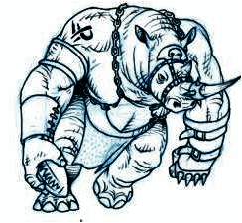
Moving Models

Moving a model a number of squares up to their movement stat is one action. Models can move diagonally. Models cannot move through a squares containing other models (except balls), but are free to move through squares adjacent to them without any penalty. Models cannot leave the board (as there’s a bleeding huge arena wall festooned with spikes, stopping them from doing so. Never mind the magical shield over the arena to prevent attacks on the Dark Lords themselves.).

When models are moved/forced on from reserve (see the game type section – section 4) they are placed on the player entrance square. They can then perform either one or two actions depending on whether there are opposing models nearby (see above).

Moving Balls

The ball is represented by a model or counter. If a model enters a square that contains the ball, then they pick it up. This counts as one action in addition to moving (and hence the model has to stop moving) if there are any opposing models adjacent to the ball. If this isn’t the case, it doesn’t count as an action, and the model is free to continue its move.

When a model is carrying the ball, their attack and defence ratings are both reduced by one. They are still free to attack other models, but they’re encumbered, distracted or preoccupied with holding the ball.

If a model in possession of the ball is reduced to zero wounds for any reason than it has just been the victim of a successful pinch (see below), than the owning player may place the ball in any adjacent square, as long as it does not already contain another model.

If the model in possession of the ball is removed from play then the ball is placed in the square where the model last was.

Throwing the Ball

Throwing the ball is one action. To throw a ball, count the number of squares between the thrower and the catcher as though you were trying to move the model there in the shortest number of squares, in a straight line.

- Balls can be thrown up to 10 squares
- For throws of 1-4 squares, the thrower must roll one skull on one dice
- For throws of 5-8 squares, the thrower must roll 2 skulls on 2 dice
- For throws of 9 or 10 squares, the thrower must roll 3 skulls on 3 dice
- You may reroll dice if you have models with high agility throwing and catching the ball. Add together the two models Agility scores, then subtract 6 from the total. This many dice may be re-rolled once each. If it is a negative number, the opponent may re-roll that many of the dice instead of the person throwing!

If too few skulls were rolled, then the ball goes askew and the opposing player places the ball in the square of the catcher, and can then move it two squares in any direction for every shield the catcher failed to roll. However, the ball is not allowed to end up in any square containing a model, or go into a goal square, or out of the arena.

Attempting to catch the ball counts as an action, regardless of whether the catch was successful or not. The catcher therefore may only perform one action in its next go.

A model can also attempt to throw the ball into an unoccupied square. In this case, use the thrower’s agility (as there is no catcher). This is not as accurate as throwing the ball to another model, and as such the thrower’s agility is reduced by one. The ball is placed up to two squares away from the target square by the opponent.

Scoring with Ball

To score a goal the model in possession of it has to move into one of the allotted goal squares and spend an action. When the goal is scored the player is free to finish his turn, although normally he/she/it will spend any remaining actions gyrating their groin at their opponents whilst miming appalling acts of barbarity regarding their opponents’ parents. This is duly appreciated by both the watching crowd of serfs and the owning Dark lord, and typically a player who performs a particularly offensive victory dance can expect to receive the favours of his dark lord that evening in the form of food, slave girls (or whatever) or just not being tortured for once.

At the start of the next turn place the ball marker in the starting square (typically in the centre of the arena) and continue play as usual – the ball is thrown in through a trapdoor by a minion beneath the arena, or it is one of four or five on a big spike, or whatever!. Deathball is a violent game and the players won’t stop pummelling each other for something as trivial as a ball being posted through a hole in the arena wall. It’s up to you to have someone handy to mooch the new ball and score the next goal, whilst stopping your opponent from doing the same!

Note: If you are playing a ‘friendly’ match or just training your team, you can stop play and reposition all survivors after each goal, as per the start of the match. Dead players should be replaced with fresh ones generated or chosen as you wish.
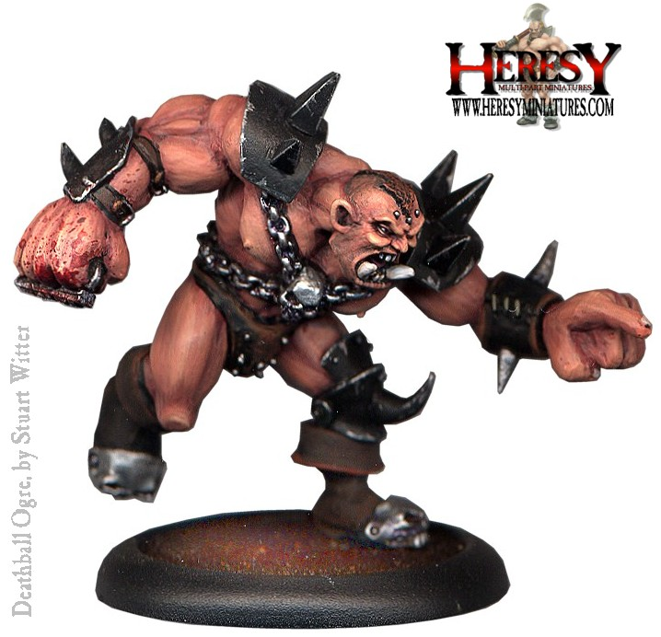
Tackling

If a model is adjacent to an opponent, and it has an action available to spend, then it can attempt a tackle. There are two forms of tackle in Deathball – the punch and the pinch, each with their own tactical advantages. Note that you can’t attempt the pinch on someone without the ball.

The Punch The tackling model rolls a number of violence dice equal to their offence, and the defending model a number of defending dice equal to their defence. Compare the number of skulls rolled by the attacker to the number of shields rolled by the defender. If the number of skulls is greater, then the defender takes a number of wounds equal to the difference. You can attack models that have been reduced to zero wounds, in fact it’s encouraged and always gets a cheer from the assembled serfs. The number of defence dice of a model on zero wounds is reduced by 1 (to a minimum of 1) as they’re unable to defend themselves properly whilst stunned.

The Pinch The tackling model rolls a number of violence dice equal to their agility, and the defending model a number of defending dice equal to their agility. Compare the number of skulls rolled by the attacker to the number of shields rolled by the defender. If the number of skulls is greater, then the attacking model takes possession of the ball and the defending model takes one wound (regardless of the difference).

You may perform more than one tackle in a turn – so you can ‘pinch’ the ball, then ‘punch’ the downed player, for example…!

Making People Bleed

Models with a positive number of wounds remaining are still very much alive and kicking.

Models reduced to zero wounds are rolling around the floor, bawling their eyes out or perhaps cowering in the hope they won’t be hit again. Models on zero wounds require an action to get back on their feet and take a further part in the game. Models on zero wounds can still be attacked, and when doing so their defence is reduced by one to represent their inability to properly protect themselves. When a model on zero wounds stands back up, they go back up to one wound. Models with zero wounds are not considered for the purposes of determining how many actions opposing models can perform.
Note: A model with zero wounds can’t hold onto the ball, it is placed in an adjoining square.

If a model is reduced to -1 wound then they are removed from play. The fighter has been dragged out the arena and is awaiting the attention of the magic sponge. At the start of every turn roll a violence dice for the model, and if it comes up with a pentagram, the player is restored to one wound, and is available as a substitute (see the game type section below for details of fielding substitutes).

A model reduced to -2 wounds or less is dead, (unless they were undead, in which case they become undeader). They can’t come back into play.

Don’t! It’s a trap!

Each violence dice has one pentagram on one of its sides. Whenever a player rolls three or more dice, and gets 3 or more pentagrams (6s), then the model has activated a dastardly trap in the arena (even if it’s only one). Roll two d20 one at a time and consult the dastardly trap generator to determine what evils the Dark Lords have in store. Resolve the effects from the table immediately, and then (if possible) finish performing the action that triggered the trap. If the trap means that the model has to perform another action (such as a chasm) then do not resolve the action that triggered the trap.

DASTARDLY TRAP GENERATOR
D20 | The trap contains: | D20 |  | Effect
1 | A magic-swirly-whirly | 1 | rift in reality | Remove the model from play (and reality if possible). The model counts as dead.
2 | A big pit containing a | 2 | helltiger | The helltiger makes a one-off attack against the model, count as a “pinch” using five violence dice.
3 | A cunningly-concealed | 3 | spear trap | Count as a “pinch” using three violence dice.
4 | A gigantic, granite | 4 | falling slab | Model must take an agility test, and roll at least two shields else they are crushed to death.
5 | A scorpion-infested | 5 | Pit full of spikes | Model takes a wound, and must spend an action climbing out of the pit
6 | A cartoon-style | 6 | chasm | Model must spend an action in order to climb out of the put.
7 | A foul-smelling | 7 | gas cloud | The model can have perform no more actions this turn or next turn as they cough and hack
8 | A potentially-harmless | 8 | trip wire | The model falls over if it was making a move action, and must spend an action dusting itself off, else no effect.
9 | A crappy little | 9 | mouse trap | The dark lord rolls his eyes despairingly at the imagination of the arena’s architect. No effect.
10 | A conveniently-placed | 10 | magic potion | Resolve the current action, and then make a bonus action (even if it isn’t the model’s turn)
11 | An irritating | 11 | Slicing Blade | The blade makes an attack with 3 dice against the victims agility in dice, Victims may use Acorbatics to re-roll
12 | A fairly inconvenient | 12 | Poison Dart Trap | Hundreds of tiny darts tipped with spider venom blast upwards into the victim. Roll 2 dice for damage, no save allowed.
13 | An unexpected | 13 | Catapult trap | Spoinggggg!!!! The victim is hurled out of the arena (even through the ceiling or magic dome) and lands far, far, away,never to return. Possibly to provide something with a takeaway meal, but definitely not to return.
14 | A quite delightful | 14 | Bucket of … | 1-3 Foul Waste. Victim must miss a turn whilst it tries to wipe it from its eyes. Eeeww!  4-6 Acid. 1 wound, no save allowed
15 | A thoroughly evil | 15 | Unnamable Terror | Oh dear . A huge fanged THING grasps the victim and pulls it into another dimension (or just swallows it). The victim counts as dead, and drops the ball in an adjacent random square if it was carrying it before it disappears forever.
16 | The Devil’s own | 16 | Fireball Trap | Treat as a magic missile attack on the victim.
17 | An unprecedented | 17 | Pool of quicksand | Glug, glug…gurgle…silence. The ball floats. The quicksand hardens after it has drowned its victim.
18 | Somewhat-clichéd | 18 | Giant Leech | The leech immediately attempts to suck all the blood from the victim’s body. Treat as an attack with 6 dice. The victim can pull the leech off if he/she should survive the attack. Does not work on skeletons/zombies
19 | A truly hilarious | 19 | refreshing drink and a sandwich | Cheers. Looks like the trap-maker has absently mindedly left his cup of tea and a bacon sarnie where some implement of doom should have been. God knows what he had for dinne then. The paranoid victim must miss a turn whilst he /she/it waits for this ‘deadly trap’ to go off. Or eats it, if it’s a prisoner…
20 | Something even the Dark Lords fear…a | 20 | Doomsday Device | The victim and anyone within 2 squares is caught in a huge explosion of magical energy that inflicts 3 skulls of damage upon them.

SECTION 2
Teams and Games

What you play with
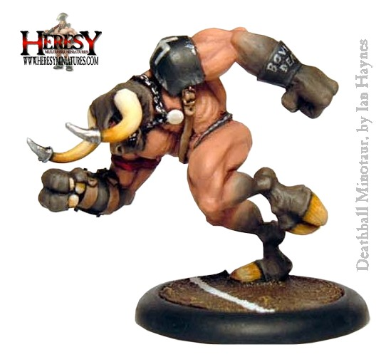
A standard Deathball team has eight models, six of which can be in the arena at any given time. For one-off games, players can generate their teams using the Team Generation table or choose them as they wish if they prefer. (A ‘gold cost’ system will be forthcoming later, representing the amount of training and torture the Dark Lord has lavished upon his team before sending them to be slaughtered).

This table is meant to randomly determine which slaves, creatures and followers that a dark lord has at his disposable. For now it only covers the models in the Heresy range, a larger one will be put in place later! If you prefer to pick teams, either choose at leisure a good mix or decide between yourself and your opponent what to use.

To use this table roll a d100 to select the type of player, prisoner, pet, minion or dark servant, thn roll another d100 to pick the exact creature that will be part of your team. Repeat this process eight times, or as many times as you have decided to use. If using a ‘random, endless’ process, just roll each time you bring on a new player . If you don’t have the model available, then you are free to substitute the model for one in the same class higher up (lower number) on the chart – for example, if you roll a skeleton, then you could substitute it for an imp or a feral.

Morica is a big place, and Deathball is a chaotic game. Violence in the arena is not just limited to scheduled matches. As a result there are many variants on Deathball, but here are the most common.

First to three sacrifices - The players keep playing until someone scores three sacrifices/goals. If models are killed, they are replaced with fresh models, either rolling on the generation table or recycling or whatever you've got in your painted collection! This one puts the emphasis on scoring over killing.

Last man standing - The winner is the player who has the most sacrifices/goals when the last player on one team is killed. Injured players may be recycled as substitutes, brought on when available and the number of models in the arena drops below its usual number. You may not score sacrifices after the opposing team are all dead, and you may not kill your own team members to rush things towards victory - Baal wants to see some genuine competitive play!

The following ideas are also fun games to play. Feel free to improvise with whatever models you’ve got in your own collection.

Irtish Helldog - An entertaining half-time show from the city of Irtiz; One team (consisting entirely of prisoners and dregs) is lined up in their own half, between two altars, the other half consists entirely of creatures with the Animal skill, or Minotaurs and Ogres. The team of prisoners must get a single sacrifice on the furthest opposite altar, i.e. not the two nearest to the ones beside them, if you follow me, before they all die. Prisoners aren't recycled, monsters are! The starting ball is given to one member of the prisoner team instead of being in the middle.

Erm, we're not meant to be here - A party of questing adventurers stumble into the arena having taken a wrong turn. The prisoner portion of the various players suddenly realise they can escape in the confusion, but the dark lord has other plans, and isn't best pleased at the disruption. You’ll probably want half a dozen adventurer figures and some well-armed guard models.

Race against time - Oh no, the big game is coming up soon but the beast-keepers left the gates unbolted! It is a race against time to herd them all back in time using prisoners as bait before the dark lord notices and makes his displeasure felt.

Go, Greased Halfling, Go! The regular severed head/ball/whatever is replaced for this peasant-pleasing demo match with a series of unfortunate halfling prisoners (or gnomes or even kobolds at a pinch), who are bound tightly with rope, able only to sprint about the place and try to stay alive for as long as possible. The teams that are competing are composed entirely of monsters such as ogres minotaurs, trolls, hurn demons and trogs. The team that skewers the most halflings within a set number of turns win the favours of their dark masters. The halflings always move away from any monsters, and use their dodge ability as much as they can. Being greased, they are still just as hard to hang onto despite the ropes!

Drink Responsibly! Over 18's/etc only. Every time someone gets killed and/or every time a dastardly trap shows up, everyone takes a drink! Don't play Deathball and Drive!

